1. There is clearly a cipher text in flag format given.
2. Hint is in the description; ROT13 is a variation of the Caesar Cipher.
   1. ROT13 is a simple letter substitution cipher that replaces a letter with the 13th letter after it in the alphabet. ROT13 is a special case of the Caesar cipher which was developed in ancient Rome.
3. Go to https://www.dcode.fr/caesar-cipher
   1. Paste cipher-text into decoder field.
   2. Click on decrypt button.
4. Under “+13” (letters shifted by 13 spaces) in the results on the left hand of the web page, a legitimate flag can be found.

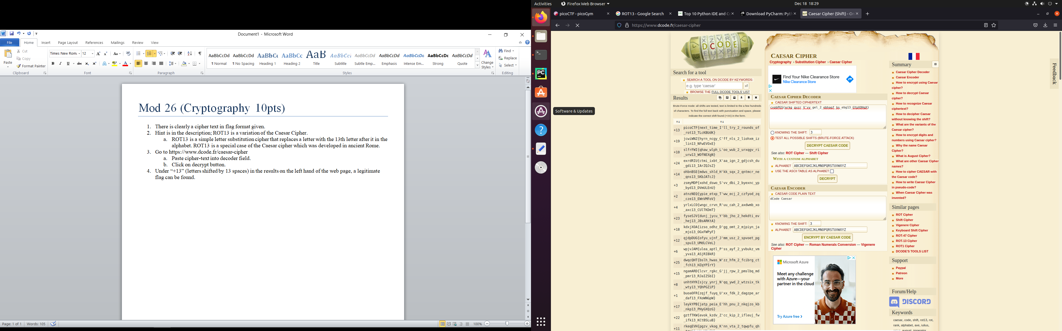

4

3b

3a